**Lab # 03**

**OBJECT**

***Examine the Functionality of the TCP and UDP Protocols***

**TOPOLOGY:**

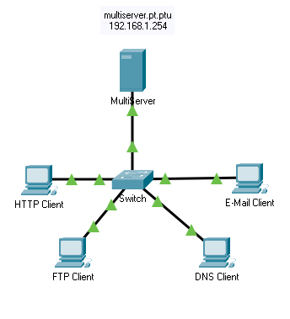

**LAB TASK:**

**Part 1: Generate Network Traffic in Simulation Mode**

**Part 2: Examine the Functionality of the TCP and UDP Protocols**

**Part 1: Generate Network Traffic in Simulation Mode and View Multiplexing**

### Step 1:  Generate traffic to populate Address Resolution Protocol (ARP) tables.

Perform the following task to reduce the amount of network traffic viewed in the simulation.

1. Click **Multi-Server** and click the **Desktop** tab > **Command Prompt**.
2. Enter the **ping -n 1 192.168.1.255**command. You are pinging the broadcast address for the client LAN. The command option will send only one ping request rather than the usual four. This will take a few seconds as every device on the network responds to the ping request from MultiServer.

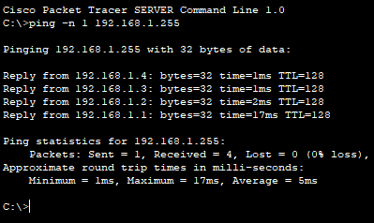

1. Close the **MultiServer** window.

### Step 2:  Generate web (HTTP) traffic.

1. Switch to Simulation mode.
2. Click **HTTP Client** and open the **Web Browser** from the desktop.
3. In the URL field, enter **192.168.1.254** and click **Go**. Envelopes (PDUs) will appear in the topology window.
4. Minimize, but do not close, the **HTTP Client** configuration window.

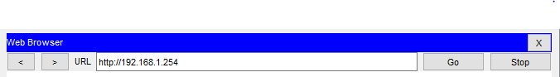

### Step 3:  Generate FTP traffic.

1. Click **FTP Client** and open the **Command Prompt** from the desktop
2. Enter the **ftp 192.168.1.254** command. PDUs will appear in the simulation window.
3. Minimize, but do not close, the **FTP Client** configuration window.



### Step 4:  Generate DNS traffic.

1. Click DNS Client and open the **Command Prompt**.
2. Enter the **nslookup** **multiserver.pt.ptu** command. A PDU will appear in the simulation window.
3. Minimize, but do not close, the **DNS Client** configuration window.

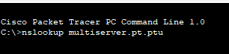

### Step 5:  Generate Email traffic.

1. Click **E-Mail Client** and open the **E Mail** tool from the Desktop.
2. Click **Compose** and enter the following information:

1)      **To:** user@multiserver.pt.ptu

2)      **Subject:** personalize the subject line

3)      **E-Mail Body:** personalize the Email

1. Click **Send**.
2. Minimize, but do not close, the **E-Mail Client** configuration window.

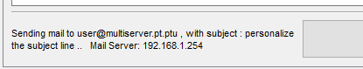

### Step 6:  Verify that the traffic is generated and ready for simulation.

There should now be PDU entries in the simulation panel for each of the client computers.

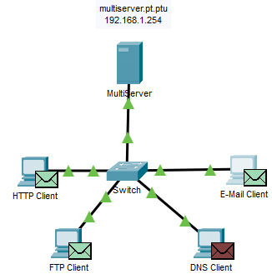

### Step 7:  Examine multiplexing as the traffic crosses the network.

You will now use the **Capture/Forward button**in the Simulation Panel to observe the different protocols travelling on the network.

**Note**: The **Capture/Forward** button ‘ **>|** ‘ is a small arrow pointing to the right with a vertical bar next to it.

1. Click **Capture/Forward**once. All of the PDUs travel to the switch.
2. Click **Capture/Forward**six times and watch the PDUs from the different hosts as they travel on the network. Note that only one PDU can cross a wire in each direction at any given time.

Q1) What is this called?

Ans) It is basically called Conversation Multiplexing.

Q2) A variety of PDUs appears in the event list in the Simulation Panel. What is the meaning of the different colors?

Ans) Different colors represent different protocols.

**Part 2: Examine Functionality of the TCP and UDP Protocols**

### Step 1:  Examine HTTP traffic as the clients communicate with the server.

1. Click **Reset Simulation**.
2. Filter the traffic that is currently displayed to only **HTTP** and **TCP** PDUs. To filter the traffic that is currently displayed:

1)      Click **Edit Filters** and toggle the **Show All/None** button.

2)      Select **HTTP** and**TCP**. Click the red “x” in the upper right-hand corner of the Edit Filters box to close it. Visible Events should now display only **HTTP** and**TCP**PDUs.

1. Open the browser on HTTP Client and enter **192.168.1.254** in the URL field. Click **Go** to connect to the server over HTTP. Minimize the HTTP Client window.
2. Click **Capture/Forward** until you see a PDU appear for HTTP. Note that the color of the envelope in the topology window matches the color code for the HTTP PDU in the Simulation Panel.

Q3) Why did it take so long for the HTTP PDU to appear?

Ans) Because TCP must first establish the connection so that HTTP traffic can begin

5. Click **Capture/Forward** until you see a PDU appear for HTTP. Note that the color of the envelope in

the topology window matches the color code for the HTTP PDU in the Simulation Panel.

Q4) What is the section labeled?

Ans) TCP.

Q5) Are these communications considered to be reliable?

Ans) Yes.

### Step 2:  Examine FTP traffic as the clients communicate with the server.

1. Open the command prompt on the FTP Client desktop. Initiate an FTP connection by entering **ftp**

**192.168.1.254**.

1. In the Simulation Panel, change **Edit Filters** to display only **FTP** and**TCP**.
2. Click **Capture/Forward**. Click the second PDU envelope to open it.

Click the **Outbound PDU Details** tab and scroll down to the TCP section.

Q6) Are these communications considered to be reliable?

Ans) Yes.

1. Record the **SRC PORT**, **DEST PORT**, **SEQUENCE NUM**, and **ACK NUM** values.

**SRC PORT: 1026**

**DEST PORT: 21**

**SEQUENCE NUM: 0**

**ACK NUM: 0**

Q7) What is the value in the flag field?

Ans) 1025, 21, 0, 0. SYN.

1. Close the PDU and click **Capture/Forward**until a PDU returns to the **FTP Client** with a checkmark.
2. Click the PDU envelope and select **Inbound PDU Details**.

Q8) How are the port and sequence numbers different than before?

Ans)21, 1025, 0, 1 SYN+ACK. The source and destination ports are reversed, and both sequence and acknowledgment number is 1.

1. Click the **Outbound** **PDU Details** tab.

Q9) How are the port and sequence numbers different from the previous results?

Ans) 1025, 21, 1, 1. The source and destination ports are reversed, and both sequence and acknowledgment numbers are 1.

1. Close the PDU and click **Capture/Forward**until a second PDU returns to the **FTP Client**. The PDU is a different color.
2. Open the PDU and select **Inbound PDU Details**. Scroll down past the TCP section.

Q10) What is the message from the server?

Ans) “ Welcome to PT Ftp server”.

### Step 3:  Examine DNS traffic as the clients communicate with the server.

1. Repeat the steps in Part 1 to create DNS traffic.
2. In the Simulation Panel, change **Edit Filters** to display only **DNS**and**UDP**.
3. Click the PDU envelope to open it.
4. Look at the OSI Model details for the outbound PDU.

Q11) What is the Layer 4 protocol?

Ans) UDP

Q12) Are these communications considered to be reliable?

Ans) NO

### Step 4:  Examine email traffic as the clients communicate with the server.

1. Repeat the steps in Part 1 to send an email to **user@multiserver.pt.ptu**.
2. In the Simulation Panel, change **Edit Filters** to display only **POP3, SMTP**and**TCP**.
3. Click the first PDU envelope to open it.
4. Click the **Outbound PDU Details** tab and scroll down to the last section.

Q13) What transport layer protocol does email traffic use?

Ans) TCP.

Q14) Are these communications considered to be reliable?

Ans) Yes.

Q15) What email protocol is associated with TCP port 25? What protocol is associated with TCP port 110?

Ans) SMTP, POP3.